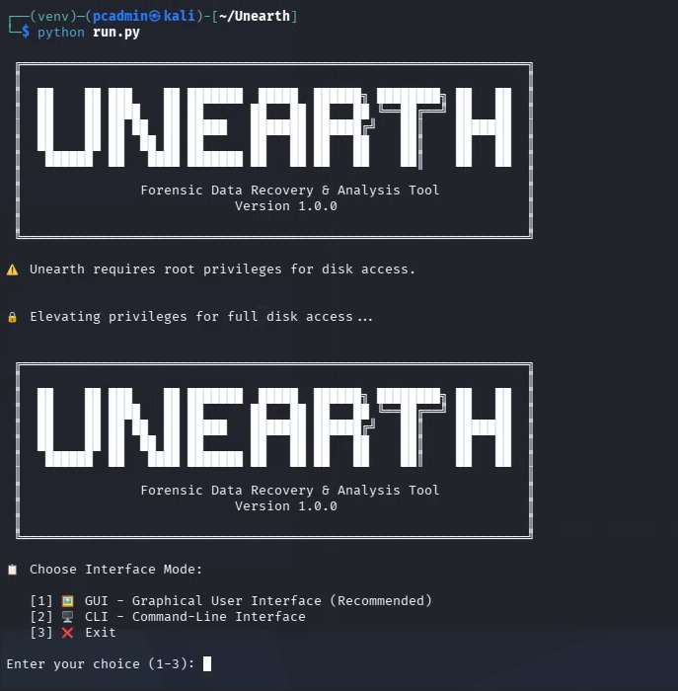
Unearth doesn’t run on GUI mode and doesn’t run on cli either

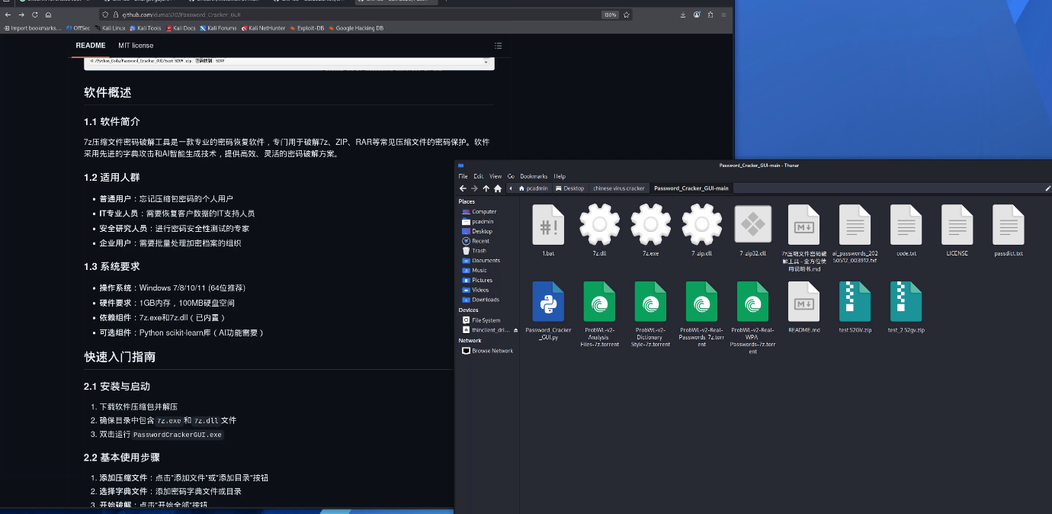
Chinese password cracking tool is lacking the exe file to be able to run it – also its in Chinese so I can’t even troubleshoot it.

Nvm it runs